11 tips to cope with anxiety about coming out of lockdown
Easing of lockdown will allow us to get back to the people and things we love, but it's OK if you feel worried about going back to something more "normal" as lockdown restrictions loosen.
The coronavirus (COVID-19) outbreak has been hard for us all and we have all experienced the effects differently, including those of us who have been shielding.
Even positive change can lead to anxiety, and it can take time to readjust to things we have not done for a while.
Feelings of post-lockdown anxiety are likely to pass with time as we get used to the "new normal" but it's important to do what we can to take care of our mental health.
There are lots of things that can help you to manage these feelings and make it easier to adjust.
Here are our top tips for taking care of your mental health as things change.
On this page
1. Go at your own pace
2. Do not avoid things entirely
3. Get your information from the right sources
4. Discuss any changes with others
5. Make time to relax
6. Challenge unhelpful thoughts
7. Tell someone how you feel
8. Plan social occasions
9. Find routine where you can
10. Write down your thoughts
11. Focus on the present
Further support
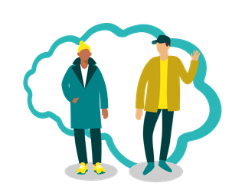
1. Go at your own pace
It might be tempting to make lots of plans and say yes to everything as things start to open up, but there's no need to rush.
Take it step by step, and only do what is comfortable and safe for you to ease back into socialising – then you can build your time back up as your confidence returns.
2. Do not avoid things entirely
Avoiding the things that make us anxious can sometimes feel like the easier option in the short term, but this can make it harder to start facing our fears in the longer term.
Instead, try to set yourself small but manageable targets – like meeting 1 person for a coffee or snack outside, or getting a haircut – and gradually build up from there.
It can help to confide in a friend or family member so they can support you to overcome your anxieties.
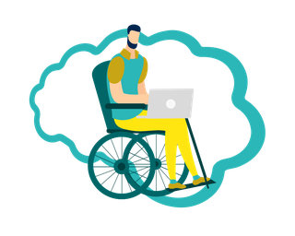
3. Get your information from the right sources
Lots of conflicting and confusing information about COVID-19 and the easing of restrictions, makes it hard to know what you can and cannot do or who to trust.
If you are not sure what is or is not allowed, stick to trusted sources like GOV.UK and the NHS COVID-19 pages for the most up-to-date information.
GOV.UK: What you can and cannot do
4. Discuss any changes with others
Before socialising with others, talk about the situation with them to make sure everybody is on the same page about what feels comfortable.
If you live with other people, it's a good idea to talk to them about changes to restrictions as well. Being aware of everybody's fears and expectations can help to avoid conflict.
If you are worried that changes to restrictions may put pressure on your family, help for parents is available.
Young Minds: For parents
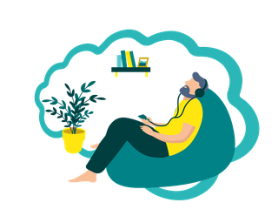
5. Make time to relax
Being able to see more of our friends and family, and visit places that might have been closed until now, is exciting. But it can also be a lot to take in all at once, so it's important to find regular time for yourself to relax too.
Video: Progressive muscle relaxation
This audio-only video will guide you through an exercise to help you recognise when you're starting to get tense, and how to relax your body and mind.
Text versionTranscript
Share
Play Video
Displays the text version below the video
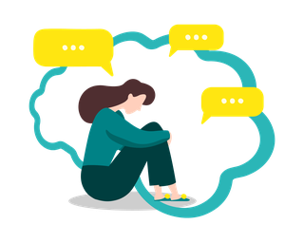
6. Challenge unhelpful thoughts
It's natural to feel worried every now and again, but our anxious thoughts can sometimes be unhelpful.
If you can learn to identify and separate unhelpful thoughts from helpful ones, you can find a different way to look at the situation. Watch our video to find out more.
Video: Reframing unhelpful thoughts
This short video will give you some practical tips on how to challenge your thoughts and start to break unhelpful cycles.
Text versionTranscript
Share
Play Video
Displays the text version below the video
7. Tell someone how you feel
It's easy to feel isolated or lonely when we're struggling. However, chances are that someone we know feels exactly how we do too.
Opening up to a person we trust can be really helpful, whether it's a friend or family member, a GP or an organisation's helpline or online forum.
If you are not ready to start socialising but are feeling lonely, there's plenty of support out there, like the Let's Talk Loneliness Campaign, and people you can speak to at any time.
NHS-recommended helplines
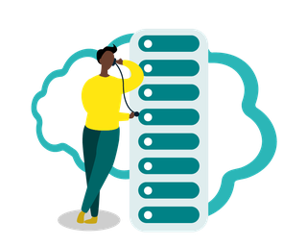
8. Plan social occasions
Uncertainty can be hard to manage but making plans can help you avoid this. Preparing for any challenges ahead of time can help us to feel more comfortable and confident in what we're doing.
That "plan" can be as simple as knowing what time an event will start and finish, and how many people are likely to be there.
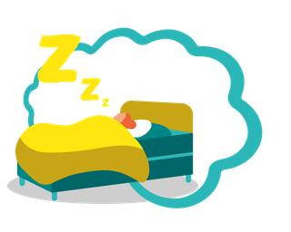
9. Find routine where you can
During lockdown, life changed for us all and we developed new routines. Even if your normal weekday or weekend habits begin to change again now, some things can stay the same.
Are there areas in your life where it's easier to stick to a routine? Something as simple as going to bed and waking up at the same time each day or making sure to stick to your set lunch break can make a big difference.
Video: Tips for sleeping better
Get simple tips for improving how you sleep with our video.
Text versionTranscript
Share
Play Video
Displays the text version below the video
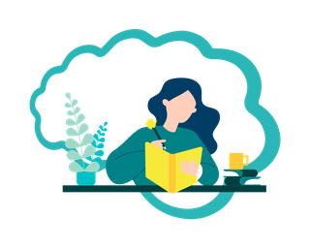
10. Write down your thoughts
If you're feeling worried or upset it can be helpful to explore your feelings by keeping a diary or journal.
This can also be a great way to track your mood over time and remind yourself of the progress you have made. As your confidence begins to grow, you can look back over your entries to see how far you have come.
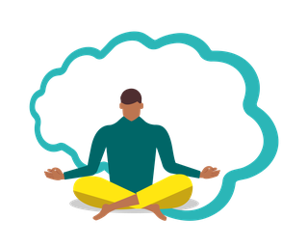
11. Focus on the present
When there is lots of change happening, we can get caught up in worrying about the future and the past.
Instead, try to shift your focus to the present – make plans but try not to dwell on "what ifs" or what was "supposed" to happen. Relaxation, mindfulness or getting outside and enjoying nature are all good ways to help you focus on the present.
Video: Mindful breathing
Mindfulness and meditation help you to be in the present. The mindful breathing exercise in this video can help you feel more calm.
Text versionTranscript
Share
Play Video
Displays the text version below the video
Further support and advice
Our pages on common mental health issues and COVID-19 have lots more tips and advice, as well as support if you're a parent or caregiver for a child or young person or helping others with mental health problems.
If you or one of your loved ones needs more support, the NHS is here to help. You can access NHS talking therapies for common mental health problems, delivered by IAPT services, by self-referring online or through your GP. Services have and will continue to be open throughout the COVID-19 outbreak.
Talking therapies are also available to older people, and translation or multi-lingual services might be available for those whose first language is not English.
If you or a loved one are experiencing a mental health crisis, you can find an urgent local NHS mental health helpline to call for 24-hour advice and support, or visit our urgent support page.
The following resources may be helpful for those with disabilities or autism:
- Learning Disability England
- The National Autistic Society has coronavirus support for autistic people and their families and an autism helpline
- Autistica has a guide for coping with the uncertainty of coronavirus, which includes an easy-read version
If you do not live in England
Additional country-specific COVID-19 guidance is available for Scotland, Wales and Northern Ireland.
How to fall asleep faster and sleep better

Looking after children and young people

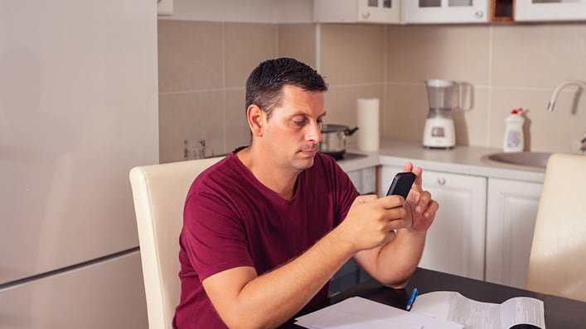
How to deal with change and uncertainty

